Academic Year: 2024-25 | Year: First Year | Term: I
Roll No.: | 11
Name: | Riddhee Sandeep Kulkarni
Subject: FCP
Assignment No.: | 25
Title: | Student Database
Date:

Contents
1. Theory (Logic) 2
2. Pseudo Code 2
3. Program Code 2
4. Output 2
5. Conclusion 2

THEORY:

This code displays student database using structure. It includes details such as name, roll number,

and marks in different subjects.

PSEUDO CODE:

Step 1: Start

Step 2: define structure

Step 3: define main function

Step 4: accept data from user

Step 5: print output

Step 6: end

PROGRAM CODE:

#include <stdio.h>

struct Students

{

char name[50];

int rollno;

int math;

int phy;

int fcp;

}s[5];

int main()

{

int i,n;

printf("Enter the number of students: ");

scanf("%d",&n);

printf("Enter student record\n\n");

for(i=0;i<n;i++)

{

printf("Enter name: ");

scanf("%s",&s[i].name);

printf("Enter roll no: ");

scanf("%d",&s[i].rollno);

printf("Enter marks in maths: ");

scanf("%d",&s[i].math);

printf("Enter marks in physics: ");

scanf("%d",&s[i].phy);

printf("Enter marks in fcp: ");

scanf("%d",&s[i].fcp);

}

printf("Student record\n\n");

printf("\n");

for(i=0;i<n;i++)

{

printf("Name: %s\n",s[i].name);

printf("Roll no: %d\n",s[i].rollno);

printf("Marks in maths: %d\n",s[i].math);

printf("Marks in physics: %d\n",s[i].phy);

printf("Marks in FCP: %d\n",s[i].fcp);

printf("\n");

}

return 0;

}

OUTPUT:

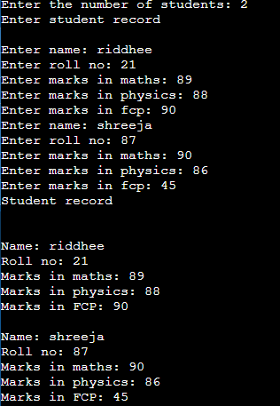

CONCULSION:

Code is run successfully, required output received

